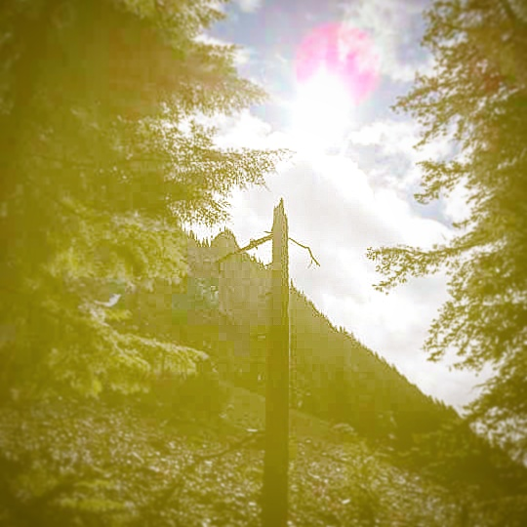

### Details at

Energy adjustment & Pangu Shengong instruction for underprivileged children & their families

# www.gofundme.com/qigongathon

# www.meetup.com/The-Art-of-Life-Force-a-Pangu-Yoga-Qi-Gong-Meetup/

With all of the negativity, fear, and violence that is happening in the US and beyond, local Pangu Shengong practitioners are inspired to help disadvantaged populations living in survival mode.   On [**Saturday, November 12th**](https://www.meetup.com/The-Art-of-Life-Force-a-Pangu-Yoga-Qi-Gong-Meetup/events/234529720/) **,** we will have a kick off Qi-Gong-Athon fundraiser where we will practice together for up to three hours.  **Please sponsor us!**

     With the money raised, Cristen Bopp will create a 501(c)(3) North Carolina nonprofit corporation and facilitate a Triangle Pangu Shengong community outreach program.  **Participating teachers will give energy adjustments and Pangu Shengong instruction to disadvantaged children and their families.**These services are empowering tools to overcome adversity and trauma.

**What is Pangu Shengong (Qi Gong)?**   It is a simple, highly effective and easy-to-learn method of energy cultivation that improves health, well-being and vitality. With its fundamental philosophy and practice rooted in kindness and benevolence, it is designed to absorb the beneficial energy of the essential qi of the universe, regulating and enhancing one’s Life Force and immunity.  Anyone of any age or ability may participate.

**Look ahead, do you see the Golden Hill?  There, support awaits.  Peaceful, calm, nourishing, golden light, extinguishing fears.  Giving wisdom, love, joy.**

## Saturday, November 12, 2016

QI-GONG-ATHON

Golden Hill Foundation Fundraiser

10 am-1 pm

919-621-5589

601 Westwood Drive Garner